Incorporating social media into a tenure & promotion narrative

Jonathan B. Singer, Ph.D., LCSW

When I submitted in March 2016, I was not familiar with anyone else who had included a social media section in a tenure narrative. I discussed my social media in the service section of my tenure narrative. I assumed that people at the school and university level would be unfamiliar with social media in general and the use of social media as a tool for service and scholarship. I used this section as a way of educating the reader and to provide data about the reach and influence of my social media posts as a form of service. Today I might place this in scholarship under “social scholarship.”

# Social Media

I consider my active use of social media, including Twitter, Facebook, Google Plus, and the Social Work Podcast innovative service to the professions of social work and suicidology. I use social media to disseminate accurate information and counter misinformation, about the profession of social work, consumers of social services, and the field of suicidology.

One measure of the value of this service is the number of people reached. Although numbers are not the only measure of service, it is one of the ways that impact is currently measured on social media. One way I separate my personal and professional life online is by using social media as the Social Work Podcast. The following stats provide some context for the reach of each of these networks. As of March, 2016:

* Twitter: 8,500 followers
* Facebook: 9,000 “likes” / “fans”
* Social Work Podcast (www.socialworkpodcast.com): 1500 unique visitors per day (not including bots or spiders), 45,000 episode downloads per month.

The podcast downloads place it in the top 8% of all podcasts. For comparison, the top 1% of podcasts includes This American Life, Fresh Air, Radiolab, and TED Radio Hour. The podcast has been in the iTunes Top 10 for Social Science podcasts since 2007. There are no comparable stats for Facebook and Twitter, although I would consider my followers to be “moderate” in size. One of the metrics used to measure reach and impact on social media is the number of followers, and the other is the amount of engagement with content (i.e. posts or tweets). The greater the reach, the more valuable the service. I provide the following examples as illustrations of both the type of content I share and the reach.

*Twitter.* Figure 1 is a screenshot of the reach / impressions of my tweets for every day in November 2015. Impressions are twitter-speak for someone seeing your tweet. If one person sees one tweet it counts as one impression. If one person sees 10 tweets it counts as 10 impressions. In November 2015, my tweets earned 261,600 impressions, with an average of 8,700 impressions per day.

**Fig. 1** Twitter analytics for @socworkpodcast from November 2015

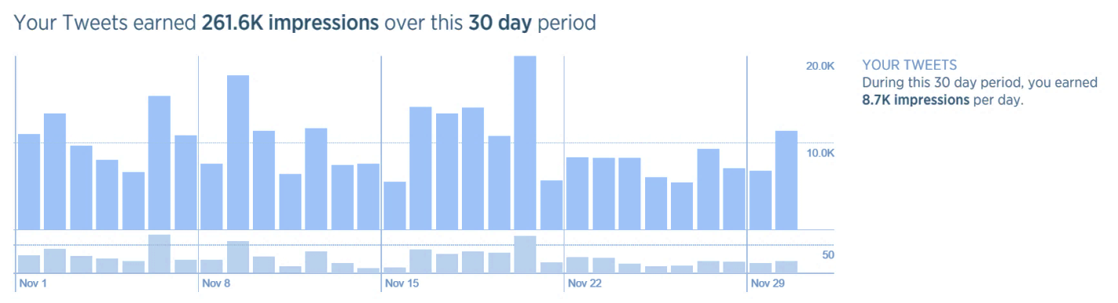

The following is an example of the reach of social media: One of the tweets I posted in November 2015 had an image of NASW’s 10 recommendations for engaging media professionals. As illustrated in Figure 2, the tweet had 1,601 impressions (meaning it reached 1,601 people), and 15 people retweeted it (meaning they thought it was important enough to share with their followers).

**Fig. 2** Twitter analytics for November 2015 NASW Tweet.

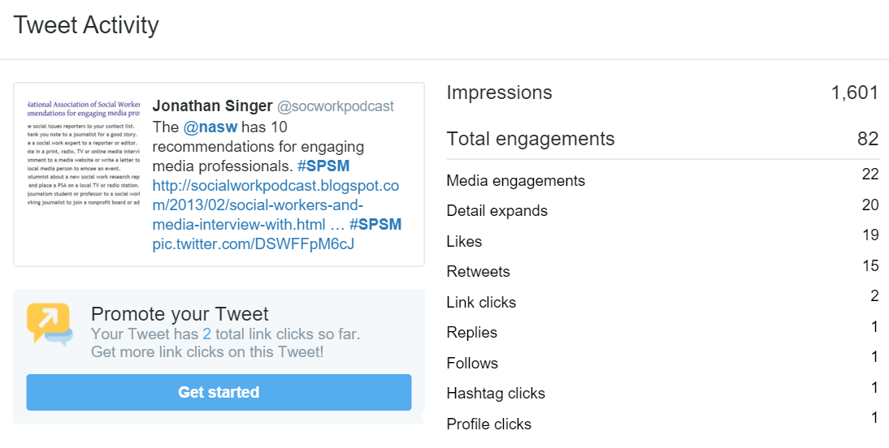

*Suicide Prevention and Social Media (#SPSM).* In 2014 I joined a nascent group of mental health professionals who were interested in using social media, particularly Twitter, for suicide prevention. The group hosts weekly tweet chats and a synchronous live video Google Hangout. The one-hour Sunday night tweet chats have between 4 – 6 million timeline impressions. I have been a frequent guest moderator and am regularly recognized as a “top influencer” in the tweet chats, with up to 800,000 impressions in an hour. In March 2016, the SPSM chat was the focus of an article on Symplur.com (Symplur tracks healthcare related content on social media using hashtags). The author wrote, “As a community, #SPSM has answered the call to provide a safe and engaging space to discuss a sensitive topic like suicide” <http://www.symplur.com/blog/spsm-robin-williams-suicide/>.

*Facebook.* The following is an example of reach on Facebook: On February 23, 2016 I shared a post on the Facebook page for the Social Work Podcast entitled, “How not to be an asshole about suicide” which has excellent information about how we talk about suicide, dispelled some of the myths around suicide (e.g. suicide is not a selfish act), and gave recommendations for how to talk with people who have lost a loved one to suicide. I decided to share this article because I know from my clinical practice and research that one impediment to our collective ability to reduce the suicide rate is the ongoing shame and silence that surrounds suicide. Unless we take action to address this, people with lived experience of suicidal ideation or attempts and survivors of suicide loss will continue suffer in silence. My intention in sharing this article was to disseminate information that social workers can use to educate themselves or others in the fight against shame and silence. As illustrated in Figure 3, the post reached nearly 17,000 people. For me, the most important part of these stats is that people liked the post enough to share it with their networks. This is a form of engagement. This amplified the reach of the post by almost a factor of four (88 likes on the Facebook post, an additional 213 likes on shared posts).

**Fig. 3** Facebook analytics for post on February 23, 2016

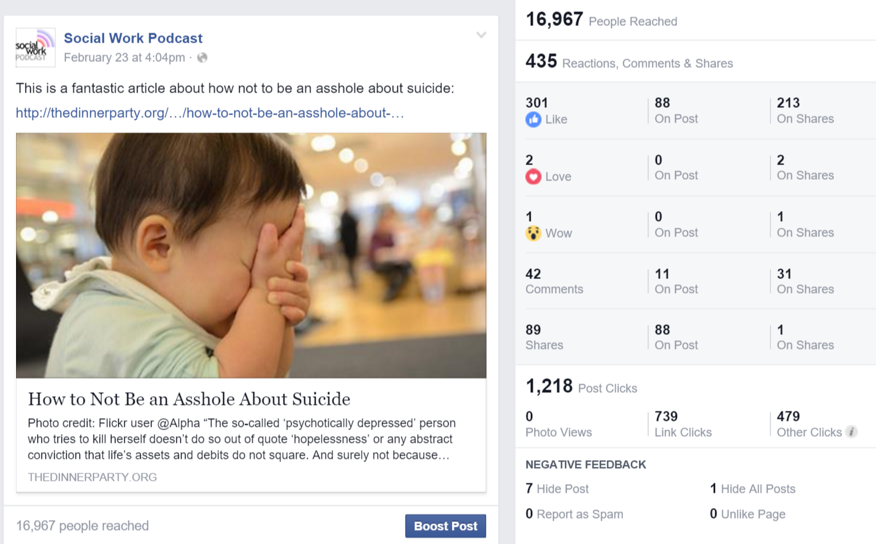

*The Social Work Podcast.* Since2007, I have provided the Social Work Podcast as a service to social work students, educators and practitioners. The 102 episodes have been downloaded over two million times by people in 181 countries and territories. The website gets approximately 1,500 unique visitors per day. I view the podcast as a service to the profession because it provides students, practitioners and educators with free, high quality social work content that they can access 24/7/365. Hundreds of listeners have emailed me over the years to tell me how the podcast influenced their decision to get an MSW, or helped them pass the social work licensure exam, or that they learned something that helped their clients. Educators have let me know that they appreciate the podcast because it provides an easy way to infuse technology into the curriculum.

My contribution to the profession via social media has been recognized by a few different organizations. In 2012, NASW awarded the Social Work Podcast the first “Media Award for Best Website.” This award represents my efforts to “raise awareness about the social work profession and issues important to social workers” via the Social Work Podcast (<http://www.socialworkersspeak.org/hollywood-connection/give-us-your-nominations-for-the-nasw-media-awards.html>). I have been identified by several websites as a “Top Social Work Academic” or “Top Social Worker” to follow on Twitter. In 2013, the University of Southern California recognized me as a “Social Work Hero” for my pioneering work with the Social Work Podcast (<https://msw.usc.edu/mswusc-blog/social-work-podcast/>). In 2014, Fordham University invited me to be a “Visiting Scholar” in the area of social work and technology.